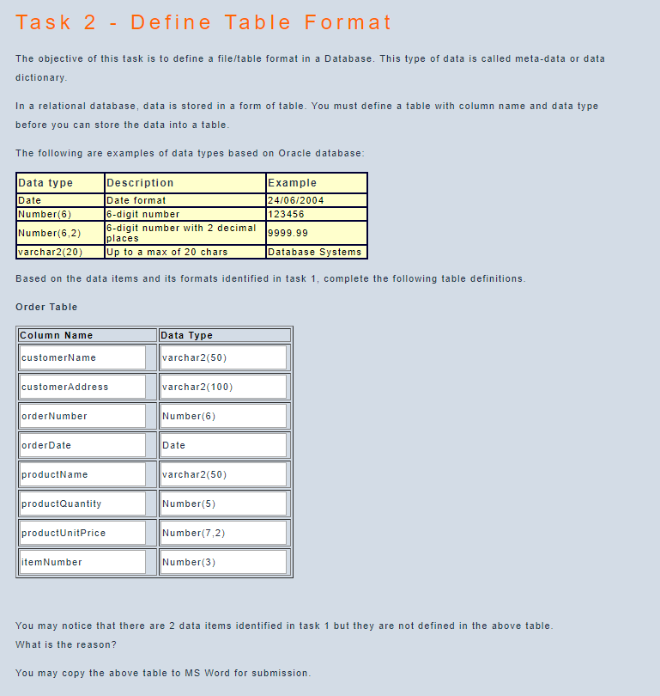

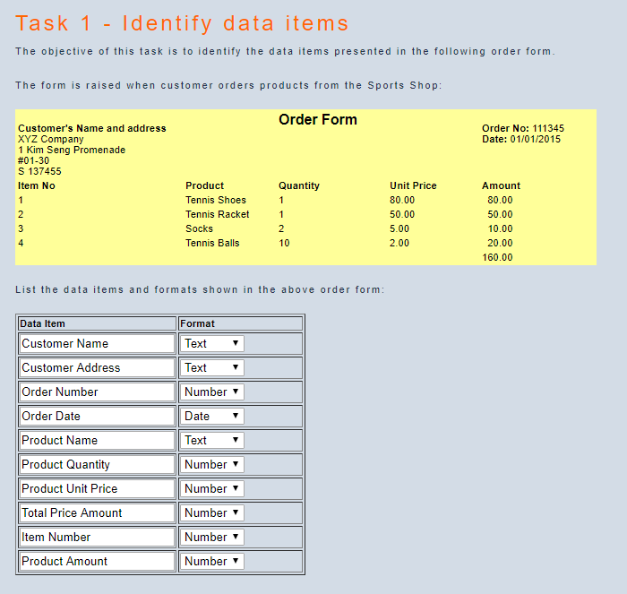

For my work, I have removed the ‘Total Price Amount’ and ‘Product Amount’.   
I removed ‘Total Price Amount’ as I feel that it is a redundant data to keep as it can be calculated by adding all the ‘Product Amount’.

I removed ‘Product Amount’ as I feel it is also another redundant data to keep as by retrieving the ‘Product Quantity’ value and multiplying it with the ‘Product Unit Price’ value, I can obtain the ‘Product Amount’.

Not to store:

ItemNo – it is a sequential no. which can be generated when printing the order

Amount – it can be computed using the raw data (qty \* unit price)

Total Amount – it can be computed by summing all the item totals

* Usually, we do not store derived data due to:
* Waste storage
* Program needs to update the derived data when the raw data is changed; otherwise, there will be inconsistency in the database
* Additional processing cost

\*\* However, sometimes we do store derived data:

* It helps to answer queries faster

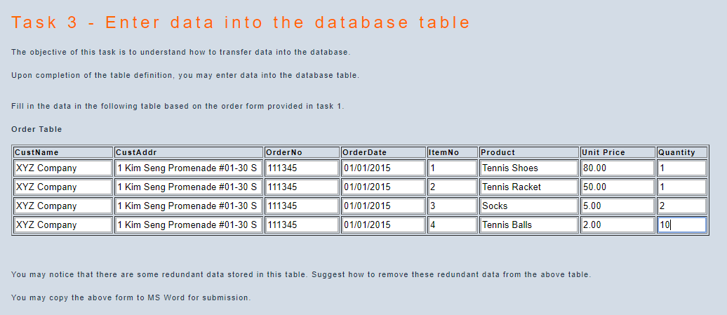

To remove redundant data, we may split the above table into:

-customer (custName, custAddr)

-order (orderNo, orderDate, custName)

-orderDetails (custName, orderNo, itemNo, qty, prodName, unitPrice)